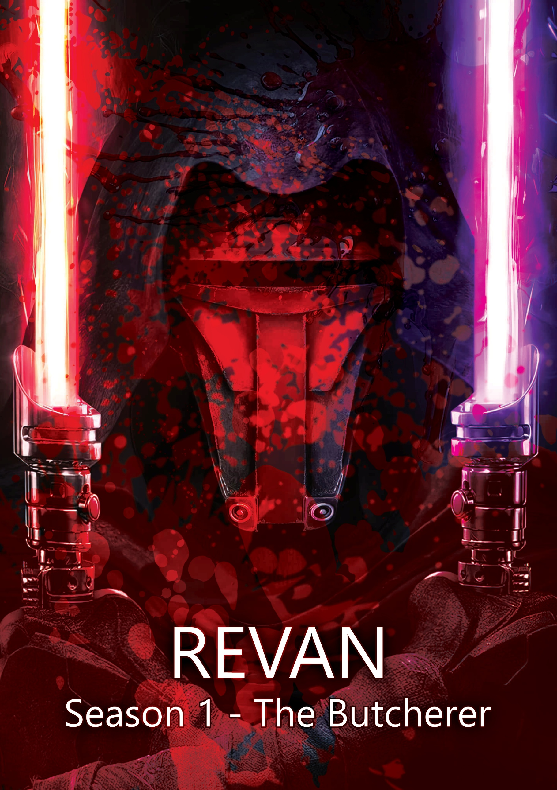

Episode 06 – Revan

We open to Revan meditating without his mask, Sith holocrons screaming spinning around him, and we enter a flash back for the episode.
We see a young Revan line up with a younger Malak, they’re both Jedi, a Mandalorian in front of them, PUT IT ONG by YEAT starts to play from the beginning of the beat drop, flashing in and out with the initial 808s and synths, as the song comes in fully we see the whole room. The Mandalorians start to shoot, and the two split deflecting and fighting the shots. Revan bullet jumps in decapitating a Mandalorian.

The rest stand in horrified shock, and Malak kills another, then they start to shoot them again. The song plays as they fight and builds, as the song builds to quiet part, Revan uses force destruction, blowing a ring of force explosion around him his fingers cracking with red force lightning, killing most of them but throwing one against a wall who lives, the song fades out. He walks up to him and lights his blade and says:

“This is for the friends I’ve lost.”

He stabs the Mandalorian killing him.

We smash cut to him in his ship; he opens holographic communications with the Jedi council who still won’t send troops to help them. Revan says:

“The Mandalorian wars are going well, we won a major victory today, securing most planetary docks on Malachor V, I urge the council to finally get involved and end this war.”

A council member turns around and says:

“The council will not get involved; this is your war Revan.”

He ends communications cutting Revan off mid word and Revan turns around and shouts:

“No of course not, because the council won’t get off its lazy ass to end a war KILLING MILLIONS EVERY DAY!”

He lights his light saber and says:

“NO, I HAVE TO DO IT!”

He throws it against the body of a Mandalorian hanging by the neck covered in graffiti. Revan walks over to him and says:

“What do you think? Am I insane for wanting a quick end to this war?”

The dead body doesn’t respond. He turns around and starts to walk then turns around to face him and says:

“What?”

He fully faces him and says:

“What did you just say to me?!”

Then strikes the body with force lightning. Revan says:

“I’m sorry I didn’t mean-“

He catches himself then runs up to his face and says:

“I’m the problem?! Really? The Jedi are cowards! Sitting in their ivory tower watching millions die when they could end this war in seconds! They’re supposed to be peacekeepers but won’t keep the peace!??”

He stands in silence the body not responding. Revan turns to it and says:

“What’s that? Maybe there’s a different way?”

He runs back over to the body and says:

“What more can I do? I’ve had to learn dark side techniques just to win a little more how much more do I need?!”

The body doesn’t respond. Revan starts laughing and says:

“Make a statement? What the fuck are you trying to say?!”

Malak, who goes under Alek as a Jedi walks in and says:

“Revan? Are you alright?”

Revan turns his eyes no longer yellow, and he adjusts his robe. Alek sees the lightsaber stuck in the Mandalorian and sees the lightning burns and says:

“Talking with a friend?”

Revan force grabs his lightsaber suddenly and says:

“The Jedi are frauds Alek, I spoke to the council and now, with a hundred Jedi in the firing line they STILL WON’T HELP US!”

Alek says:

“You can’t expect them to get involved in a war they have no stake in.”

Revan turns to him and says exhausted by angry and energetically:

“NO STAKE IN?! They’re the Jedi, a force for good and they think that they can sit on the fucking side lines and watch us do the job they’re supposed to be doing.”

Alek says:

“Yes, the council is hypocritical, oh and would you look at that! The sky is also blue. That’s crazy.”

Revan says:

“Alek I’m starting to think we shouldn’t be fighting for the Jedi anymore.”

Alek says:

“Yeah, let’s go join the Sith that’s a great idea.”

Revan says:

“Why not? They’d help us complete our goals.”

Alek stops and says:

“Revan, we’re already basically Sith, we just fight for good, but we do fight for good.”

Revan pauses and says:

“I think it’s time for a revolution.”

Alek says:

“Sure, after we’ve beaten the Mandalorians.”

Revan says:

“We can’t beat them in one-on-one combat.”

Alek says:

“Then maybe we need a new strategy?”

Revan looks up with an evil smile, then says:

“I’ll be back.”

He leaves the room. Alek looks at the hanging Mandalorian and says:

“And we’re the sane ones huh?”

He then under hand throws his lightsaber into it, taking its head off and the body drops with a thud.

We transition to Ekhralon in the current day, she’s walking through the hallways of Star Forge and Malak walks past her she turns around to him and says:

“Hey, do you know where Revan is?”

Malak turns and says:

“He’s meditating…”

She looks confused and says:

“Sith… meditate?”

Malak says:

“Well, seeing as he isn’t sith that’s not a valid point, but yes they also do.”

She says:

“What for?”

Malak says:

“Well just like Jedi, Sith meditate on what connects us to the force which for us is hatred, jealousy, desire and pain. We relive our pain and learn to use it.”

She says:

“So instead of meditating to find peace, you meditate to feel hatred?”

Malak turns around and says:

“Exactly, just don’t disturb him Ek.” (shortened as they’re now more of a group).

Ekhralon turns around and keeps walking the way she was going and turns into the mess hall, Zevarûn is sitting eating at a table alone. She walks over, grabs some food and sits down with him. He says:

“Ah the last Chiss force sensitive.”

She says:

“Ah the almost last Korriban.”

They laugh together and then he says:

“To what do I owe the pleasure?”

She says:

“Well Revan is meditating, I’ve already practiced 3 times today so I’m bored.”

Zevarûn pauses for a second and says:

“You know, I do know an ancient Sith fighting style that’s been forgotten in Jedi literature.”

She says:

“Really? The ancient sith knows ancient sith?”

He laughs and says:

“It’s for physical weapons though, not kyber ones.”

She says:

“So what’s the point?”

He says:

“Sometimes the old ways teach us more than just to kill.”

She pauses and says:

“Well sure, let’s do it.”

Zevarûn says:

“Great! Meet me in the training room in 10 minutes, I’ll show you how to fight like a true sith.”

She pauses and says:

“You called Revan a true sith, why?”

He pauses for a second and says:

“Revan believes in using the dark side of the force, not because he’s told to use it, but because it allows him to win against anyone. It’s functional which is the point.”

She says:

“And other sith aren’t real sith?”

Zevarûn says:

“Many are hyper religious, focusing on finding meaning in their connection to the force, so they focus more on that rather than it’s functional utility.”

She stands up and says:

“Interesting, so 10 minutes?”

He says:

“10 minutes.”

We cut back to the flashback and Revan is now inside of his personal jedi ship, in hyper space. His loyal fighter Meetra Surik walks up to him. He opens the conversation:

“Revan, where are we headed?”

Revan turns slowly and says:

“There’s a sith arms maker we’re visiting.”

Meetra says:

“Sith?”

Revan says:

“Surprisingly the Sith also believe that the Mandalorians are a problem, they’ve agreed to help us.”

Meetra says:

“Ah so the council didn’t agree to this decision.”

Revan says:

“No, they told me it’s my war and that they wouldn’t get involved.”

He goes dark and says:

“So, I’ll make it my war.”

Meetra says:

“The goal of this?”

Revan says:

“To finally end it, though it may do more damage than good temporarily. Is that going to be a problem?”

Meetra says:

“I trust you implicitly Revan, as always but wouldn’t the council object?”

Revan says:

“They’re going to find out the cost of objecting to war.”

Meetra pauses for a second and says:

“Revan, you have taught me more about the force in 3 months than I learned in my entire life at the temple, you know I’ll follow you anywhere, but I won’t fall to the dark side.”

Revan stands perfectly still and says:

“Meetra, you’re going to do what’s best for you, if you stay a Jedi be prepared for them to exile you, and once they have come and find me whatever side we’re on.”

Meetra says:

“Of course, Revan, I’m fully aware of my fate.”

The ship drops out of hyper space and flies down to a black ash-like planet. The dust blowing like a sand storm. The ship lands and Revan stands out, his white robe being doused in black soot. He walks towards a saloon, as he does so we see the white robe become darker and darker, he blows open the doors with the force. He then says:

“Right, I need to find a certain weapons maker that I heard lives here.”

The bar stands up and light their lightsabers. One sith says:

“Jedi aren’t welcome here.”

Revan smiles an evil smile and says:

“Who said I’m a jedi?”

And strikes him with force lightning, blowing him back, setting him on fire and killing him. Revan continues:

“Now even though we fight for different sides, we can all admit that the scourge of the Mandalorians effects all of us so if you’d be so kind to put your weapons away, it’s a fight you won’t win. I came here for a drink, not a blood bath.”

The Sith turn off their blades and sit back down as the bar’s musicians start to play again, he walks over to the bar and orders a drink. The bar tender leans over as she places the drink down and says:

“Over there.”

She points to a man with one eye sitting alone. Revan walks up to him and sits across from him. The man doesn’t look up. Revan starts by saying:

“I’m looking for a arms manufacturer who has schematics for a Mass Shadow Generator?”

The man looks up and says:

“And what makes you think I’d have such a super weapon?”

Revan smiles and says:

“Because you know what it is.”

The sith lord smiles and says:

“The schematics will cost you Jedi… dearly.”

Revan leans back and says:

“Name your price.”

He leans back mirroring him and says:

“100,000,000 galactic credits along with your nicest ship.”

Revan smiles and says:

“We have a Mandalorian ship we stole, gold inlay, mood lighting, plenty of room, comfortable chairs and as for the money, we broke into the bank of Mandalore, you’ll have it in a fort night.”

The sith laughs and says:

“You’re serious?”

Revan says:

“Of course, do I not look it?”

The Sith says:

“A Jedi wanted a mass shadow generator? How times have changed.”

Revan sighs and says:

“War changes us all. What was unthinkable yesterday, is necessary today.”

The sith pauses and says:

“The black looks good on you.”

We transition back to Ekhralon and Zeravûn in the training dojo. He begins by saying:

“An ancient sith weapon isn’t like a lightsaber, it has real weight in the blade, but it’s perfectly balanced.”

Ekhralon watches him balance the blade on his finger, he then continues:

“The sith sigils on the blade invoke different force elements, they are what turns a normal piece of metal into a weapon that still works to this day.”

The golden sigils on the blade reflex against the light. Ekhralon says:

“What do they mean?”

Zeravûn says:

“Their meanings have been mostly lost over the generations, but we know one of them… Death.”

He points to the top sigil. Ekhralon says:

“Not on the nose at all.”

Zeravûn flips the weapon around and says:

“Try it.”

She grabs the weapon and sees images of old sith lords waging war against the Jedi, like the Jedi did in the Chiss palace but she doesn’t cry. Zeravûn says:

“A weapon like this carries a history, it can invoke images of past fights, or certain events and assassinations. To wield it you are channeling history, you understand?”

Ekhralon says a little shaken:

“Yes… yes I do.”

Zeravûn starts up the droids and says:

“Alright, these droids are your typical fighting styles, the ancient style uses the weaknesses of each against them.”

Ekhralon says:

“Like Revan’s fighting style?”

Zeravûn says:

“No, Revan breaks rules of combat and deceives others, this is different you’re merely flowing with the dark side, against the light side, let the force guide you… Do you have a saber?”

Ekhralon uses the force to bring her saber out and activates it. A brilliant white blade appears. Zeravûn smiles and says:

“You really aren’t a Sith or a Jedi anymore… interesting. No matter.”

He picks up her weapon from midair and says:

“Alright, the ancient sith focused on a repetitive fighting form.”

He swipes down stepping forward, she follows, then flips the sword around the side of his body and swings back down in the opposite angle, she follows and does the same. He then turns with the weight of the blade and re-attacks forward again with a more horizontal swipe. Ekhralon follows as they repeat the sequence, in the opposite direction.

We slowly transition back to the flash back. A group of Sith use a floating transport to put a bomb on Revan’s ship. Revan has a couple of sith bring crates of credits in briefcases out of the ship and places them down. The Sith arms dealer says:

“Pleasure doing business with you Jedi.”

Revan says:

“I was recently trained on Korriban, calling me a Jedi might insult me.”

The Sith says:

“We can’t deny our fates.”

Revan laughs and says:

“I’ll being seeing you around then I guess.”

The doors of the ship close and the ship takes off. We cut to Revan sitting in a throne like chair, Alek and Meetra come up to him. Alek says:

“So, this is our master plan?”

Meetra says:

“The Shadow Generator is interesting; it’s like a gravity well. It temporarily increases the gravitation pull of the local area and cycles ripping planets apart and destroying ships.”

Alek says:

“Ah so a weapon of mass destruction. My favorite.”

Revan looks out at the planet and says:

“The mandalorians have invaded republic territory unprovoked, decided to murder all force sensitives on the planet, including children en masse, then decided to stand there and fight both Sith and Jedi to stake their claim to a planet they’ve raped!”

Meetra says:

“Yes, we all know what’s been happening the last few years.”

Revan turns around and say:

“If they want the pieces of rubble left over, they can have them but if we can’t save the planet, we surely can stop them having it.”

There’s a pause and Alek says:

“So mutually assured destruction?”

Revan smiles looking out to the planet and says:

“It’s only mutual if they can match it.”

Meetra watches this with a pause and says:

“Alright, just so I’m 100% confident, are you sure you want to use this weapon against them? It will end the war, but it is genocide, we can’t take a decision like this lightly.”

Revan turns to her and says:

“Just build the bomb, if we don’t want to use it, we can threaten that we have it and could. Either way building the bomb itself will lead to no one dying, your soul is safe Meetra.”

She sighs and walks off. Alek says:

“We’ve been out here for 3 years with no support…”

Revan watches as Alek walks over to the window. He continues:

“And to think it could all be over soon.”

Revan pauses and says:

“The journey has been long.”

Alek turns to him and says:

“Will it really be worth it?”

Revan puts his hands around his head, looks into his eyes and says:

“Never doubt yourself Alek, you’re capable of so much more than you think.”

He then leaves and Alek turns and looks out to the planet. As we fade to modern day Malak watching Ekhralon fight with the Sith sword.

She’s now fully engaged with the droids. The sword gets stuck in one of them and she uses force lightning to blow the other running at her up. Zeravûn says:

“All weapons have their weaknesses.”

Ekhralon says:

“I think I honestly prefer the lightsaber.”

Zeravûn says:

“Of course, it’s a weapon meant for combat.”

He rips the sword out of the droid and says:

“This is ceremonial, meant for executions, used in combat 2000 years ago but there’s a reason we stopped using them.”

Ekhralon says:

“Then why do you?”

Zeravûn smiles evily and says:

“It’s my culture. It's a weapon that takes immense force power to make viable today, and I do. Care to duel?”

Ekhralon force grabs her white light saber and says:

“I’d be honored.”

Zeravûn steps up to the training dojo, she bullets jumps at him and he blocks it seamlessly and force pushes her back. They circle each other and we cut to Malak leaving. He walks down to the mess hall and sits down with a sigh. He hears heels walking down the hallway to the mess and throws his lightsaber. A woman catches it and says:

“Do you treat all women this way?”

He looks up in shock and looks at her. He stands up hurriedly and runs over and says jubilantly:

“Meetra! What a wonderful surprise!”

He hugs her and she smiles and says:

“I like your new look!”

Malak laughs and says:

“It’s been so long!”

Meetra says:

“It’s been eons.”

Malak says:

“Revan is somewhere here, meditating.”

Meetra says:

“That’s alright, we can wait and catch up over smoked bantha.”

She walks over to a table with Malak and they sit down.

We transition back to the flash back. The bomb now fully finished, the three of them are staring at it. Meetra says:

“To think, we could end the war tomorrow.”

There’s a heavy pause and Revan walk away saying:

“Then let’s do that.”

The two look over their shoulders and then at each other.

We cut to the planet, Mandalorians walking around cities on the surface, the ground starts to shake and then rips open. Mountains erupt into volcanos. We see buildings crush themselves under the weight, then it cycles, making everything lighter temporarily then re-engages ripping the planet more.

We transition to Revan watching the planet rip itself apart from his ship. Ships get torn in half and ripped into the planet. Every ship in orbit is shaking. Then a bright white light appears from the surface and half of all the fleets fly into the surface crashing into the planet as it rips itself apart and implodes. The camera zooms out to show the other two watching from behind him.

We cut to his face; in the modern day, hyperventilating. A tear falls it as the sound around him cuts, we sit there for just a little longer than is needed. He takes one more breath and we smash cut to credits.

END OF EPISODE

